3

Name:________________________________ Teacher:_____________________

Date: _______________________

Cambridge High School

|  |  |
| --- | --- |
|  |  |
| Level 3 Calculus  Practice Assessment 2019  91577 Apply the algebra of complex numbers in solving problems | |

**Credits: Five** 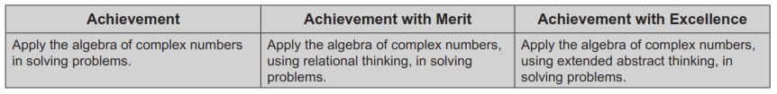

**You should attempt ALL the questions in this booklet.**

Show ALL working.

If you need more space for any answer, ask the supervisor for extra paper and clearly number the question.

|  |  |
| --- | --- |
| **Overall score** |  |
| **Grade** |  |

Check that this booklet has questions 1 to 3 in the correct order and that no pages appear to be missing.

**YOU MUST HAND THIS BOOKLET TO THE SUPERVISOR AT THE END OF THE EXAMINATION.**

**QUESTION ONE**

Assessor’s use only

a) The complex number $z=a+bi$ is shown on the Argand diagram below.

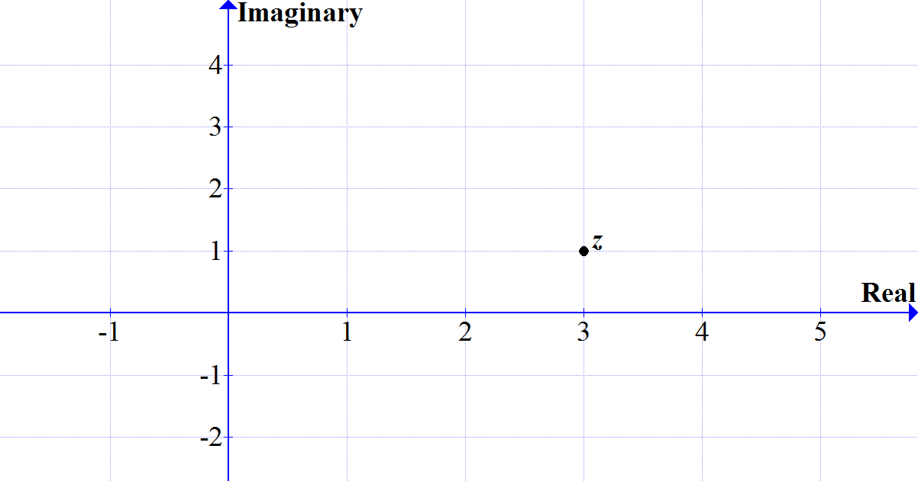

(i) Calculate $z^{2}.$

(ii) If $w=3-i$ and an angle $θ$ is formed by joining $z$ to the origin ( $0+0i)$ and then to $w$, find $cosθ$.

b) When the polynomial $x^{n}+x-8$ is divided by $x-2$, the remainder is 10.

What is the value of *n*?

c) Two of the solutions to the polynomial $z^{3}+bz^{2}+cz+d$ are 2 and $1+i$.

Assessor’s use only

Using this information, find the values of *b*, *c* and *d*.

d) If $v=6+ki$ and $w=4+ki$, find $k$ if $\arg\left(2v×w\right)=\frac{π}{4}$

.

**QUESTION TWO**

Assessor’s use only

a) Find the exact value of $x^{2}+4x+4$ when $x=2+\sqrt{3}$.

b) Write ${(1+i)}^{8}$ in its simplest polar form.

c) Given $\log_{a}2=p$ and $\log_{a}3=q$, write $\log_{a}\frac{8}{3}$ in terms of p and q.

d) Find the range of values of *x* for which $\left|x-4\right|>2$, where $x∈R$.

Assessor’s use only

e) Find the Cartesian equation of the of the point $P(x,y)$ representing the complex number $z=x+yi$, given that $2\left|z-3i\right|=\left|z\right|$.

Show that the locus is a circle, giving its centre and radius.

**QUESTION THREE**

Assessor’s use only

a) Express $\frac{x^{3}+5x-7}{x-2}$ in quotient plus remainder form.

b) Simplify $\frac{i-4}{2i-3}$ into the exact value of $a+bi$, where *a* and *b* are rational numbers.

c) Determine the value of *z* in $z-8=\left(7-2\overline{z}\right)i$, giving your answer in the form $a+bi$,

where *a* and *b* are real numbers.

d) Solve $\sqrt{-2x+8}=x$

Assessor’s use only

e) Find all the solutions for the equation, ${\left(\frac{z}{bcisπ}\right)}^{5}=2bi$ where *b* > 0.

**Assessment Schedule – 2019**

**Mathematics and Statistics: Apply the algebra of complex numbers in solving problems (91577)**

Evidence Statement

|  |  |  |  |  |
| --- | --- | --- | --- | --- |
| ONE | Expected Coverage | Achievement (u) | Merit (r) | Excellence (t) |
|  | | | | |
| (a) i) | $$8+6i$$ | Correct solution. |  |  |
| (a) ii) |  | Modulus found. | Cosine rule (or similar) used. Ignore if $\cos^{-1}0.8$ found. |  |
| (b) | $$2^{n}+2-8=10$$ $$2^{n}=16$$ $$n=4$$ | Correct solution. |  |  |
| (c) | If $1+i$ is a solution then so is $(i-i)$ So $\left(z-2\right)\left(z-\left(1+i\right)\right)\left(z-\left(1-i\right)\right)$ becomes $z^{3}-4z^{2}+6z-4$ so $b=-4, c=6 and d=-4$ | A valid method started | Correct values for *b*, *c* and *d* stated. |  |
| (d) | $$2vw=48+20ki-2k^{2}$$ $$\frac{20k}{48-2k^{2}}=1$$ $$k=2, k=-12$$**Check for solution the correct answer is k=2 (must show working)** | Line 1 | $$both k values$$ | Justification for answer |

|  |  |  |  |  |
| --- | --- | --- | --- | --- |
| **TWO** | Expected Coverage | Achievement (u) | Merit (r) | Excellence (t) |
| (a) | $${\left(2+\sqrt{3}\right)}^{2}+4\left(2+\sqrt{3}\right)+4$$ = $19+8\sqrt{3}$ | Correct answer. |  |  |
| (b) | $${(\sqrt{2}cis\frac{π}{4})}^{8}$$ = $16cis2π$ = 16 | Accept correct answer in polar form. |  |  |
| (c) | $${=log}_{a}8-\log_{a}3$$ = $\log_{a}2^{3}-\log_{a}3$ = $3\log_{a}2-\log_{a}3$ = $3p-q$ | 1 correct or consistent log rule applied. | $3p-q$ stated. |  |
| (d) | $${(x-4)}^{2}>4$$ $$x^{2}-8x+16>4$$ $$x^{2}-8x+12>0$$ $$\left(x-2\right)\left(x-6\right)>0$$ $$x<2,x>6$$ | Expanded and simplified to $$x^{2}-8x+12>0$$ | Correct solutions. |  |
| (e) | Circle centre = (0, 4)  Radius = 2 | Squares to get to: $$4\left(x^{2}+{\left(y-3\right)}^{2}\right)$$ $=x^{2}+y^{2}$. | Rearranges and completes the square either correctly or consistently: $$x^{2}+{(y-4)}^{2}=4$$ | Correct Cartesian equation for circle stated as well as recognition of centre point and radius. |

|  |  |  |  |  |
| --- | --- | --- | --- | --- |
| THREE | Expected Coverage | Achievement (u) | Merit (r) | Excellence (t) |
|  | | | | |
| (a) | $$x^{2}+2x+9+\frac{11}{x-2}$$ | Correct answer using any appropriate method. |  |  |
| (b) | $\frac{14+5i}{13}$ or equivalent | Correct answer. |  |  |
| (c) | $$x+yi-8=(7-2\left(x-yi\right))i$$ $$\left(x-8\right)+yi=\left(7-2x+2yi\right)i$$ $$\left(x-8\right)+yi=\left(7-2x\right)i-2y$$ so: $$x-8=-2y$$ $$y=7-2x$$ Hence: $x-8=-2(7-2x)$ $$6=3x$$ $$x=2, y=3$$ which becomes $2+3i$ | Simplification to: $$\left(x-8\right)+yi=\left(7-2x\right)i-2y$$ | Finding: $$x=2, y=3$$ |  |
| (d) | $$\sqrt{-2x+8}=x$$ $$-2x+8=x^{2}$$ $$x^{2}+2x-8=0$$ $$\left(x+4\right)\left(x-2\right)=0$$ $$x=-4, 2$$ Check solutions  *x* = 2 only valid solution | Squared and simplified to get: $x^{2}+2x-8=0$ . | Factorised and checked solution to get *x* = 2. |  |
| (e) | $$z^{5}=2b^{6}cis\frac{11}{2}π$$ $$z_{1}={(2b^{6})}^{\frac{1}{5}}cis\frac{-9}{10}π$$ $$z_{2}={(2b^{6})}^{\frac{1}{5}}cis\frac{-5}{10}π$$ $$z_{3}={(2b^{6})}^{\frac{1}{5}}cis\frac{-1}{10}π$$ $$z_{4}={(2b^{6})}^{\frac{1}{5}}cis\frac{3}{10}π$$ $$z_{5}={(2b^{6})}^{\frac{1}{5}}cis\frac{7}{10}π$$ | Line 1 | Any 3 correct solutions | Polar form correct and all 5 solutions stated. |

# Judgement Statement

In the external examinations the grades candidates are awarded fall within the ranges below.

|  |  |  |  |  |
| --- | --- | --- | --- | --- |
|  | Not Achieved | Achievement | Achievement  with Merit | Achievement  with Excellence |
| Score range | 0 – 8 | 9 – 14 | 15 – 20 | 21 – 24 |